**INFORMATION: Apple Power Adapters Recall**

Please be advised that Apple have issued a product recall for power adapters citing potential electric shock hazards.

The image below details how to identify the affected models of power adapters. An affected wall plug adapter has 4 or 5 characters or no characters on the inside slot where it attaches to an Apple power adapter.

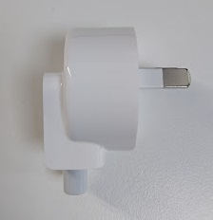

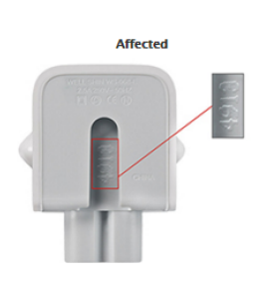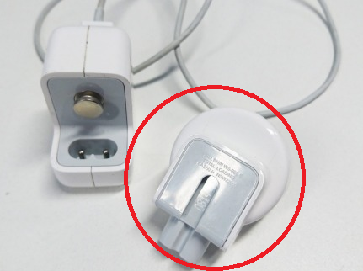

**Staff - School owned Macs**

If you are using **School owned** device issued by ICT, please call the **Oakhill IT Service Desk** to arrange for a replacement

**Students - BYOD / Personal Devices Mac**

If you are using a device purchase through **CompNow** or a **Personal Device** bought through external vendor:

Swap at an Apple Store

Pop up to any Apple store and the faulty adapter can be replaced on the spot. The closest Apple Store is Castle Towers

Replacement Online via Post

You can do this online here <https://selfsolve.apple.com/012016/#AUS> by providing the serial number of the device, Apple ID and Apple will send them a replacement through post.

Replacement at Oakhill

The School Vendor CompNow is providing no-cost exchange units in-person / via post / or as advance replacements. You can come into the IT Service Desk and we can arrange a replacement through CompNow

More information is available at the Apple website:   
<https://www.apple.com/support/ac-wallplug-adapter/>

To visit your nearest Apple Store:   
<http://www.apple.com/au/retail/storelist/>​